

#### *Project Report*

**Doctor Appointment Booking System**

**Master of science in**

**Computer Science**

Submitted By:

Gaurav Taluja (0898157)

Bhawna Chawla (0898151)

Under the guidance of

#### Dr. Q. Pang

Department of Computer Science

Lakehead University

Thunder Bay, Ontario, Canada

**ABSTRACT**

The proposed project is a Doctor appointment booking system that provides patients an easy way of booking a doctor’s appointment online. The primary objective of this system is to manage the details of Hospital, Doctor, Patient, Test, Medicine, Booking Number. It maintains all the information about the Doctor, Appointment, Booking Number. This is a web-based application that overcomes the issue of managing and booking appointments according to user’s choice. It becomeschallenging for the compounder or doctor himself in manually allotting appointments to patients as per their availability. Hence this application offers a practical solution where users can view various booking slots available and select the suitable date and time. The already booked space will be marked red and will not be available for anyone else for the specified time. It also allows users to cancel their booking anytime. The system also provides patients treatment history so that it becomes easy for the doctor to operate the patients. The doctor has to feed the system regularly with patients health information such as disease, treatment, date and time etc.

**TABLE OF CONTENTS**

**CHAPTER 1 INTRODUCTION**

1.0 Introduction …………………………………………….……..…..……………………………………7

1.1 Project Overview…….………………………………..…..……………………………………………7

1.2 Scope of project ……………..………………..………………… ………..…………………………..8

**CHAPTER 2 LITERATURE REVIEW**

2.1 Patients’ Appointment System………………………………………………………………………...9

2.2 Online Booking System………………………………………….…………………………………….9

**CHAPTER 3 METHODOLOGY**

3.1 Methodology………………………………………………………………………………………….10

3.2 Justification of Methodology…………………………………………….…………………………...10

3.3 Description of Methodology………………………………………..………………………………...11

**CHAPTER 4** **ANALYSIS, DESIGN AND DEVELOPMENT**

4.1 Introduction……………………………………………………………...……………………………12

4.2 System Analysis……………………………………………………..……………………………..12 4.2.1 User Requirement …………………………..………………..…………………………………….12

4.2.2 System Requirement …………………………….…………..……………………………………..12

4.3. System Design………………………………………………..………..……………………………..13

4.3.1 Logical Model………………………………………………………………………………………13

4.3.2 System Architecture………………………………………………..……………………………….14

4.3.3 Entity Relationship Diagram………………………………………….…………………………….15

4.3.4 Use Case Diagram…………………………………………………………………………………..16

4.3.5 Data flow Diagram………………………………………………………………………………….19

4.3.6 Screenshots……..…………………………………………………………………………………...20

4.4 System Development…………………………………………………....…………………………….26

4.4.1 Introduction to Python……………... ……………………………….……………………………...26

# 4.4.1.1 Object Orientation…………………………………………………………………………………………………..26

# 4.4.1.2 Platform Independence…….……………………………………………………………………………………..26

# 4.4.1.3 IDLE(Integrated Development & Learning Environment)………………………………………….....27

# 4.4.1.4 Python Features….…………………………………………………………………………………………………..27

# 4.4.1.5 My-SQL…………….……...…………………………………………………………………………………………….27

# 4.4.1.6 Database…………….…….……………………………………………………………………………………………27

# 4.4.2 Django ………………………………………………………………………………………………………………….……………..28

## 4.4.3 Testing……………………….……..……………………………………………………………………………………………..28

**CONCLUSION……………………………………………………………………………………….29**

**REFERENCES………………………………………………………………….…………………… 29**

# 

# 

**LIST OF TABLES**

Table: 4.1 Hardware Requirement………………………………………………………………………..12

Table: 4.2 Software Requirements…………………………………………..……………………………13

**LIST OF FIGURES**

Fig: 3.1 Methodology……………………………………………………………………………………..10

Fig: 4.3.1 Logical Model………………………………………………………………………………….13

Fig: 4.3.2 System Architecture…………………………………………………..………………………..14

Fig: 4.3.3 Entity Relationship Diagram…………………………………………………………………..15

Fig: 4.3.4 Use Case Diagram …………………………………………………………………………….16

Fig: 4.3.5 Data flow Diagram …………………………………………………………………………….19

**CHAPTER 1**

**INTRODUCTION**

The proposed project is a Doctor appointment booking system that provides patients an easy way of booking a doctor’s appointment online. The objective of this system is to manage the details of Hospital, Doctor, Patient, Test, Medicine, Booking Number. It maintains all the information about the Doctor, Appointment, Booking number. It is a web-based application that overcomes the issue of managing and booking appointments according to user’s choice. It becomes challenging for the compounder or doctor himself in manually allotting appointments to patients as per their availability. Hence this application offers a practical solution where users can view various booking slots available and select the suitable date and time. The already booked space will be marked red and will not be available for anyone else for the specified time. It also allows users to cancel their booking anytime. The system also provides patients treatment history so that it becomes easy for the doctor to operate the patients. The doctor has to feed the system regularly with the patient’s health information such as disease, treatment, date and time etc.

**1.1 Project Overview**

This project aims to create a doctor-patient handling management system that will help doctors to organize their patient's appointments and will also help patients to book doctor appointments without standing in a long queue. It provides registration and login for hospital, doctors and patients. Doctors can register themselves under hospital by giving his necessary details such as name, category, mobile number, email ID etc. This system allows doctors to manage their appointments timings online, and patients are allowed to book empty slots o online. The system maintains the appointment data for multiple doctors of various date and times. Each time a patient visits a doctor his/her medical details are stored in the database by a doctor. A doctor can view the patient's treatment history whenever he needs. At the same time doctor may view the patient’s previews medical history while the patient visits him.

The System has the following modules

* Hospital
* Doctor
* Patient

**Hospital:** Hospital needs to login with username and password and in the hospital home screen, he can see the basic functionalities of the hospital. Hospital can view the registered doctors and patients. It can also view the patient’s appointment and doctors details

**Doctor:** Doctor needs to register by giving the necessary details like, category, timing, fees etc. After registration he can log in to view the patient request forwarded from the hospital and he can also see the feedback given by patients.

**Patient:** The patient needs to register by giving the necessary details like name, address, mobile number, email and after logging on he can search for the doctor by category and name. Based on the doctor availability the system will confirm the booking and will send an email that the appointment is confirmed. The patient can also cancel the reservation and can also give feedback about the performance of the doctor.

**1.2 Scope of Project**

* The patient gets a confirmation email of appointment booking from the system.
* The system contains an extensive collection of doctor information.
* Anyone in need can get blood on time.
* The hospital can maintain computerized records without redundant entries.
* The system stores a patient’s medical history for future use.
* It is easy to operate.
* It reduces the cost of the organization to maintain the records.

**CHAPTER 2**

**LITERATURE REVIEW**

**2.1 Patients’ Appointment System**

Waiting time of a patient is defined as the length of time when the patient entered the clinic to time the patient received his or her prescription. Long waiting time is a serious problem in today’s world. Appointment scheduling started a long time ago in a health care center, it is a queuing model that is designed to minimize idle doctor time but the current appointment system focus on saving both doctor and patients idle time. The main objective of this system is to manage doctor’s time, reduce patient’s waiting time, and improve the quality of service in healthcare.

**2.2 Online Booking System**

The ordinary way of booking an appointment is via phone but with the era of IT technology and healthcare as an important system, the healthcare industry is moving towards online booking system. There are many ways to book an appointment, a person can either go to the hospital directly for consultation or him/she can make an appointment from home through a phone call. With the increasing use of the internet, many hospitals start using website appointment system. It allows a patient to create an account by giving their details, then a registered patient can log in to their account using username and password, and can select a physician, view their working hours. After choosing a physician, the patient can choose a valid date to make an appointment, then the patient will receive a confirmation e-mail about the appointment date and time. It will also enable the patients to view and monitor their medical records online. This system improves the efficiency and effectiveness of healthcare.

**CHAPTER 3**

**METHODOLOGY**

**3.1 Methodology**

* Waterfall Model

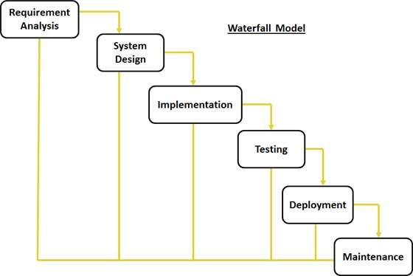

Fig-3.1 Methodology

**3.2 Justification of Methodology**

Every software developed is different and requires a suitable SDLC approach to be followed based on internal and external factors. Some situations where the use of the Waterfall model is most appropriate are:

* Requirements are clear, fixed and properly documented,.
* Product definition is stable.
* Technology is understood and is not dynamic.
* The project is short.
* Simple and easy to understand.
* Phases are processed and executed one at a time.
* Easy to arrange tasks

**3.3 Description of Methodology**

The phases in the Waterfall model are:

* **Requirement Gathering and analysis:** Possible requirements of the system are captured in this phase and documented in a requirement specification document.
* **System Design:** System design is prepared by studying the requirement specification from the first phase. System Design helps in specifying hardware and system requirements and also helps in defining overall system architecture.
* **Implementation:** With inputs from system design, the system is first developed in small programs called units, which are integrated into the next phase. In Unit Testing each unit is formed and tested for its functionality.
* **Integration and Testing:** All the units developed in the implementation phase are integrated into a system after testing of each unit. Post-integration the entire system is tested for any faults and failures.
* **Deployment of the system:** After functional and nonfunctional testing, the product is deployed in the customer environment or released into the market.
* **Maintenance:** There are some issues which come up in the client environment. To fix those issues patches are released. Also to enhance the product some better versions are released. Maintenance is done to deliver these changes in the customer environment.

**CHAPTER 4**

**ANALYSIS, DESIGN AND DEVELOPMENT**

**4.1 INTRODUCTION**

The primary purpose of the study is to find out how the processing of the patient’s data is carried out. Information is recorded manually when a patient fixes an appointment.

**4.2 System Analysis**

Doctor Appointment Booking System was categorized into user requirements, system and hardware requirements.

**4.2.1 User Requirement**

The Patients and doctors described the basic requirements of the system that includes Search for Patients, Register Patient, Update record, Doctor information record, view doctor availability record and view all types of reports

**4.2.2 System Requirement**

The hardware and software requirements required for the effective and efficient running of the system

**Table: 4.1 Hardware Requirements**

|  |  |  |
| --- | --- | --- |
| **SL** | **Hardware** | **Minimum System Requirement** |
| 01 | Processor | 2.4 GHz Processor speed |
| 02 | Memory | 2 GB RA |
| 03 | Disk Space | 500 GB |

**Table: 4.2 Software Requirements**

|  |  |  |
| --- | --- | --- |
| **SL** | **Software** | **Minimum System Requirement** |
| 01 | Operating System | Mac OS/Windows 10 |
| 02 | Database Management System | MySQL , phpMyAdmin |
| 03 | Runtime Environment | Python3 , Django |

**4.3 System Design**

After the interpretation of the data, tables were created and data is processed to guide the researcher about the implementation stage of the project. The System design ensures that only authorized users are allowed to access the systems information.

**4.3.1 Logical Model**

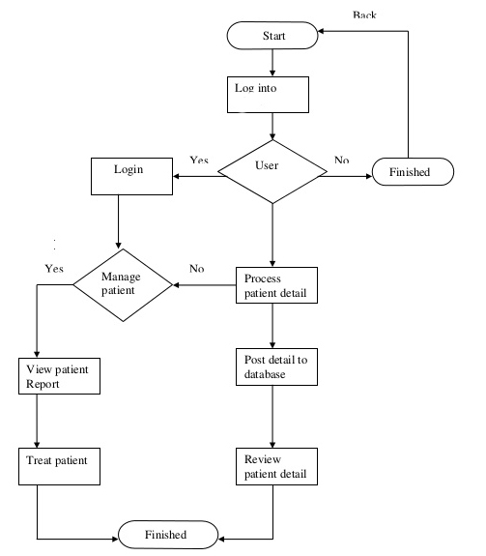

**4.3.2 System Architecture**

This architecture gives a view of each component and how they communicate with each other. This system consists of a three-tier architecture interface, process management and DBMS

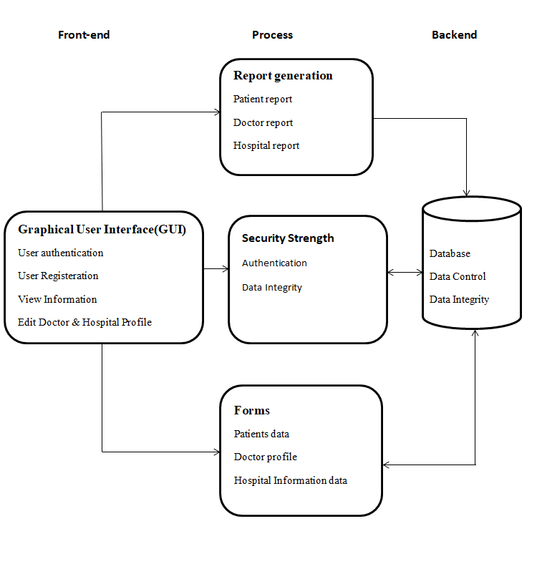

**4.3.3 Entity-Relationship (E-R) Diagram**

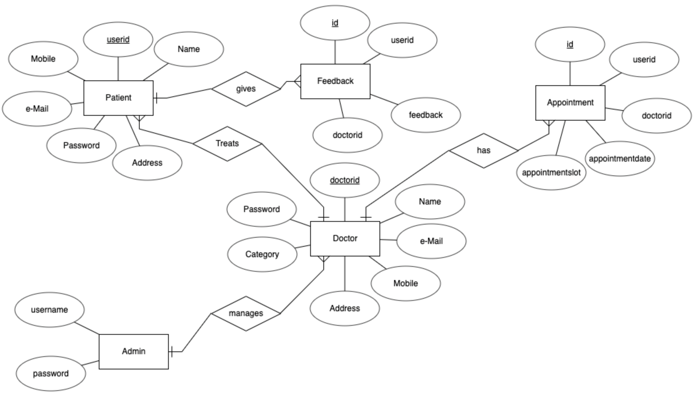

**4.3.4 Use-Case Diagram**

* **Admin Use-Case Diagram**



* **Doctor Use-Case Diagram**



* **Patient Use-Case Diagram**



**4.3.5 Data Flow Diagram**

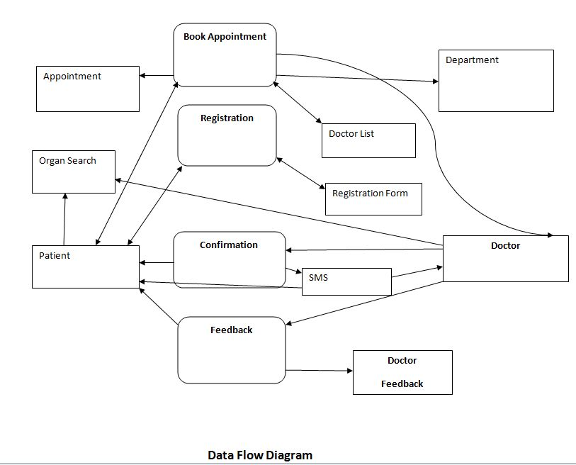

**4.3.6 Screenshots**

* **Start Page**

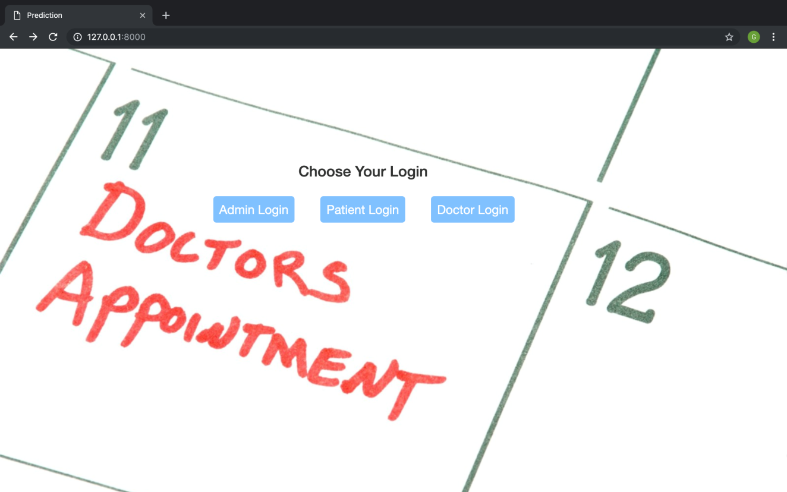

* **Admin Home**

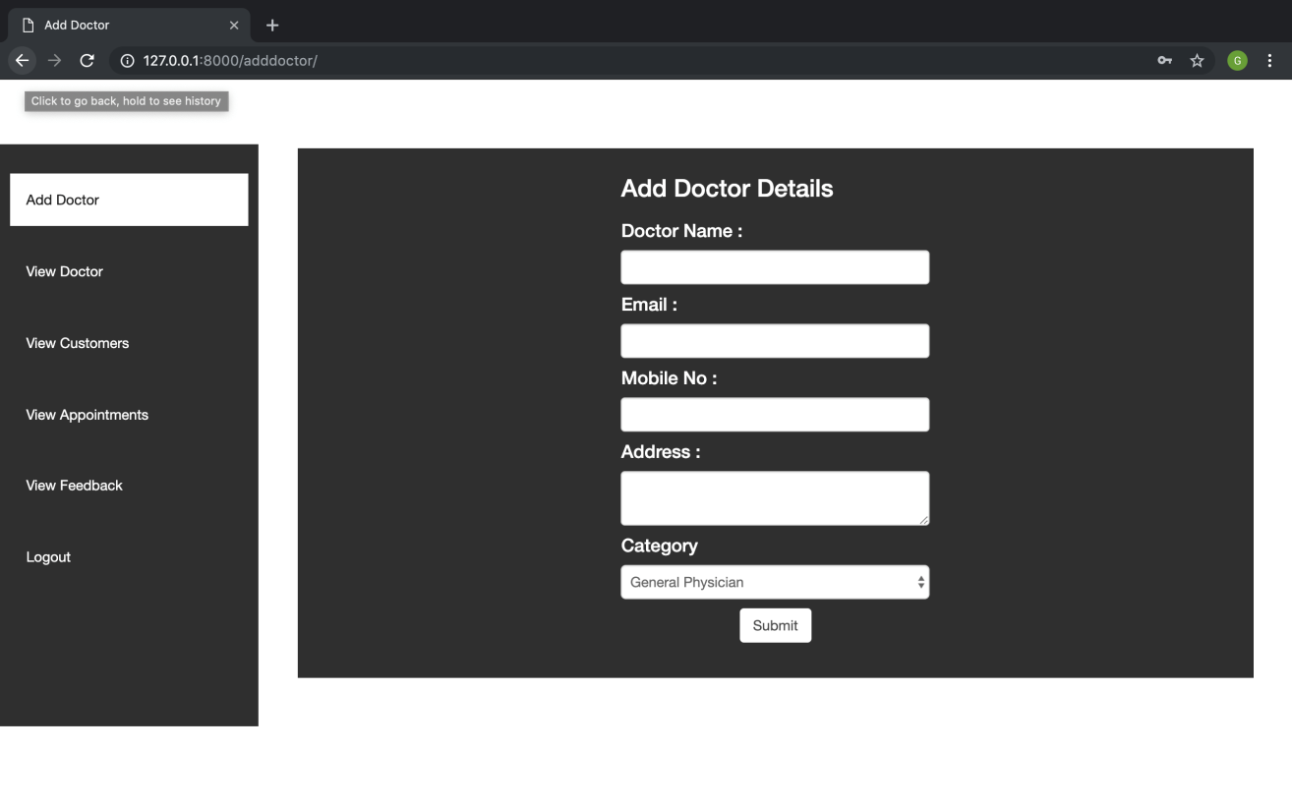

* **Admin View Doctor**

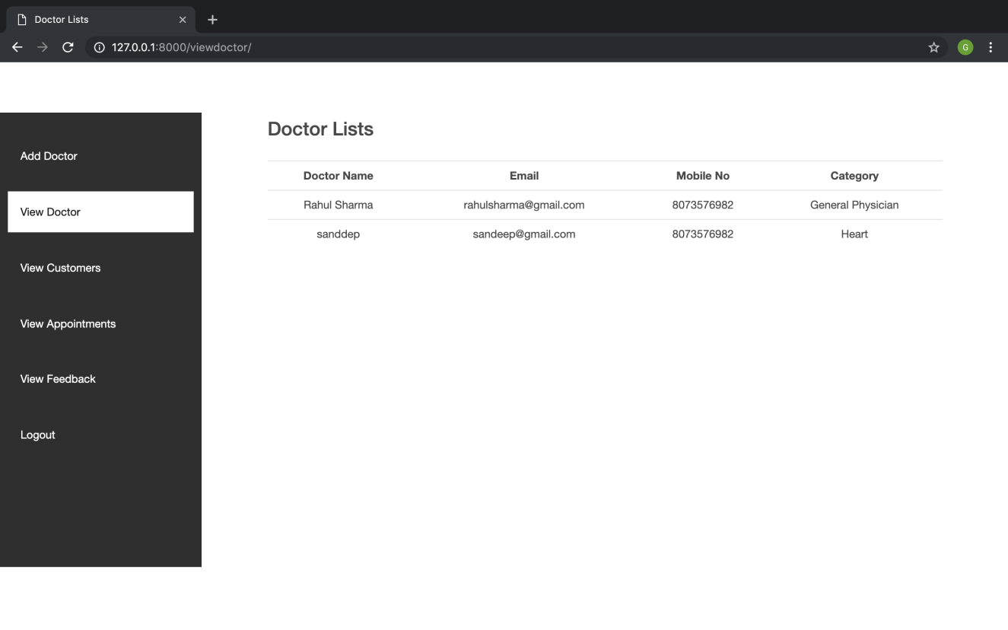

* **Admin View Patient**

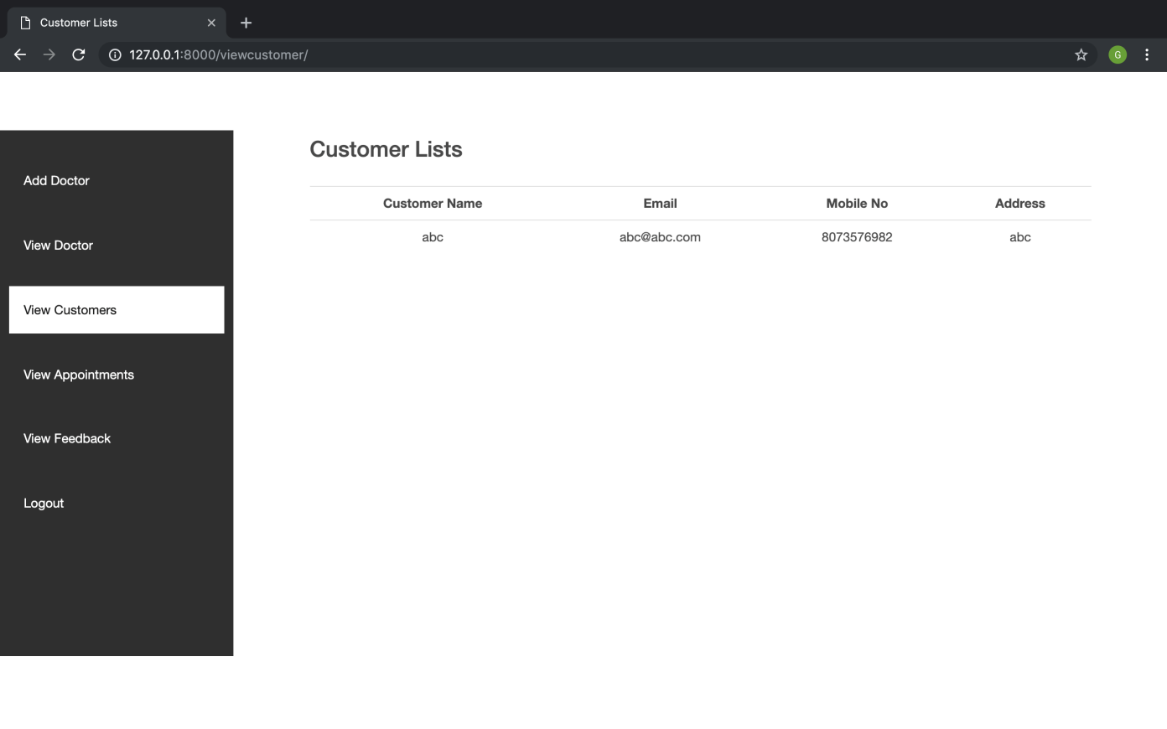

* **Admin View Appointments**

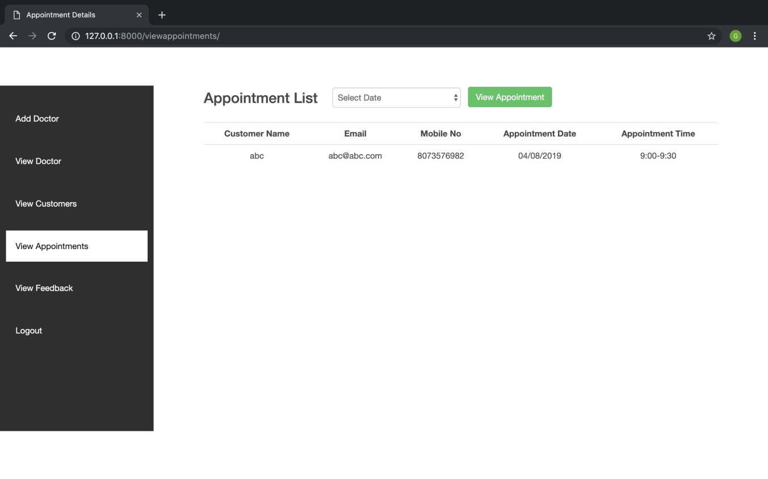

* **Patient Home**

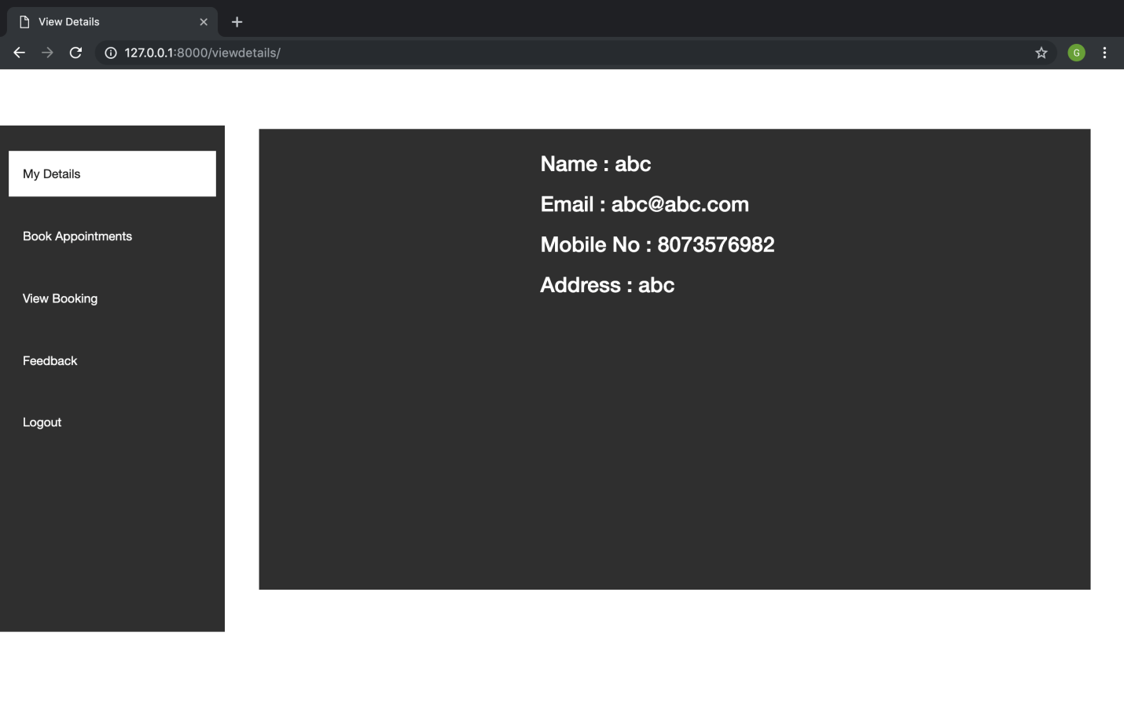

* **Book Appointment**

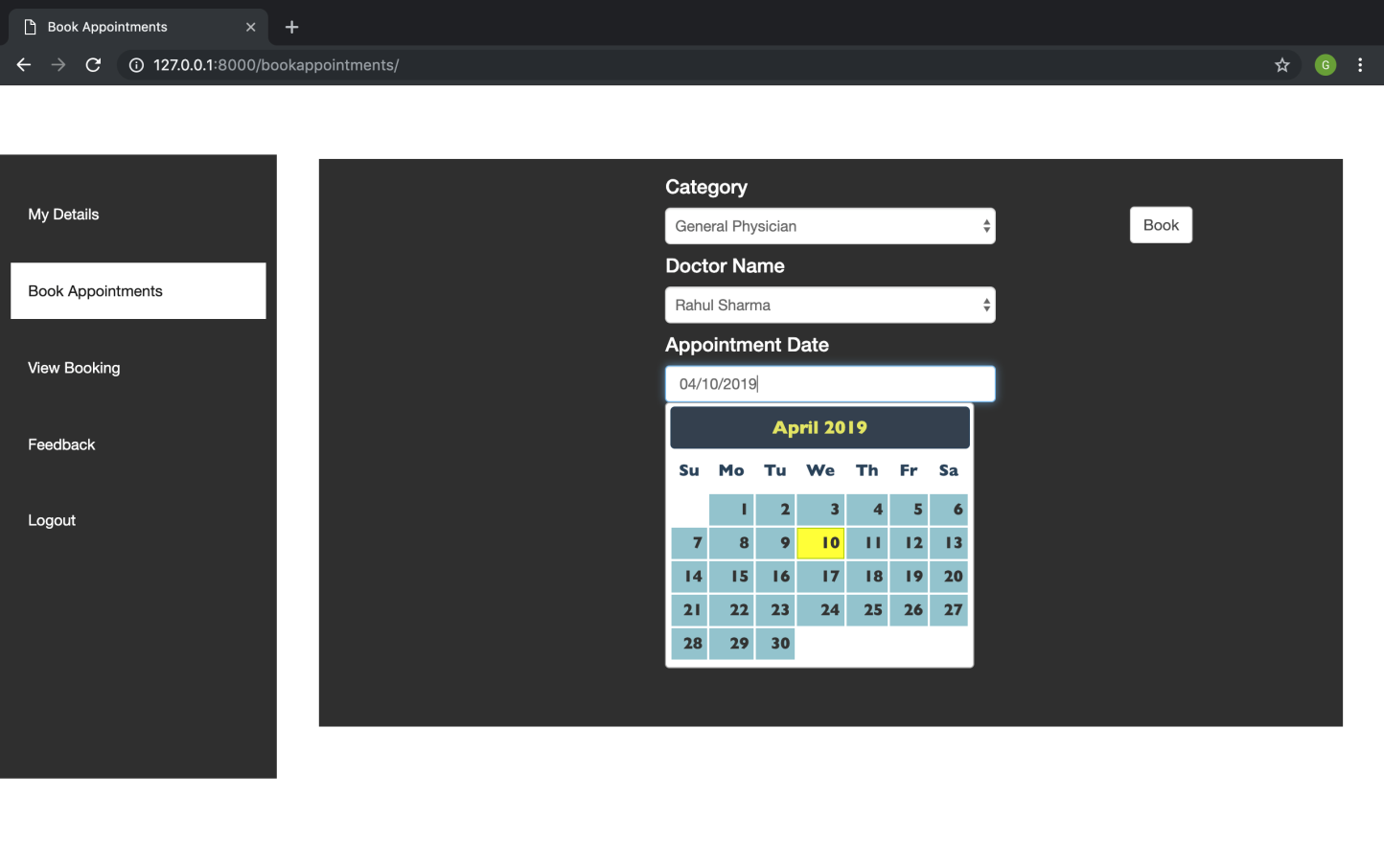

* **View Booking / Cancel Booking**

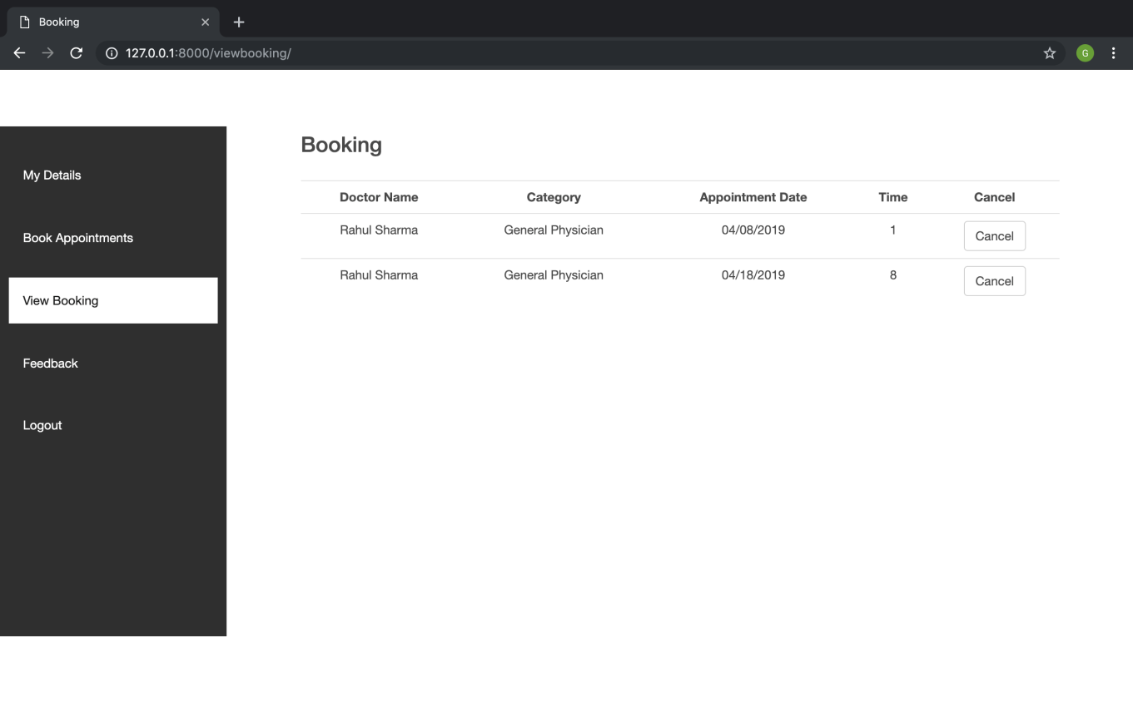

* **Feedback**

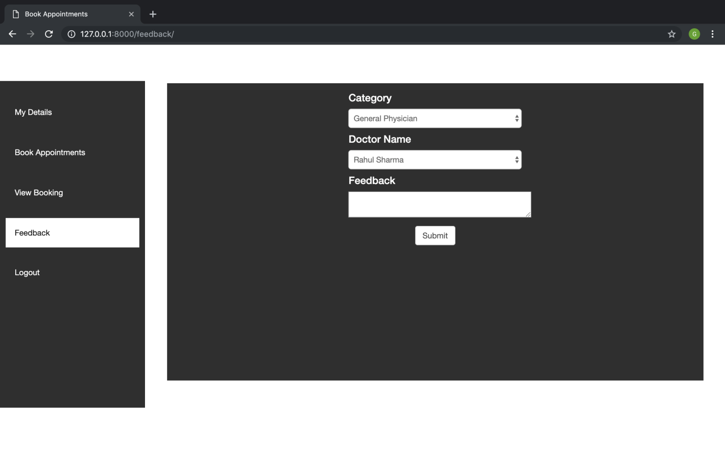

* **Doctor Home**

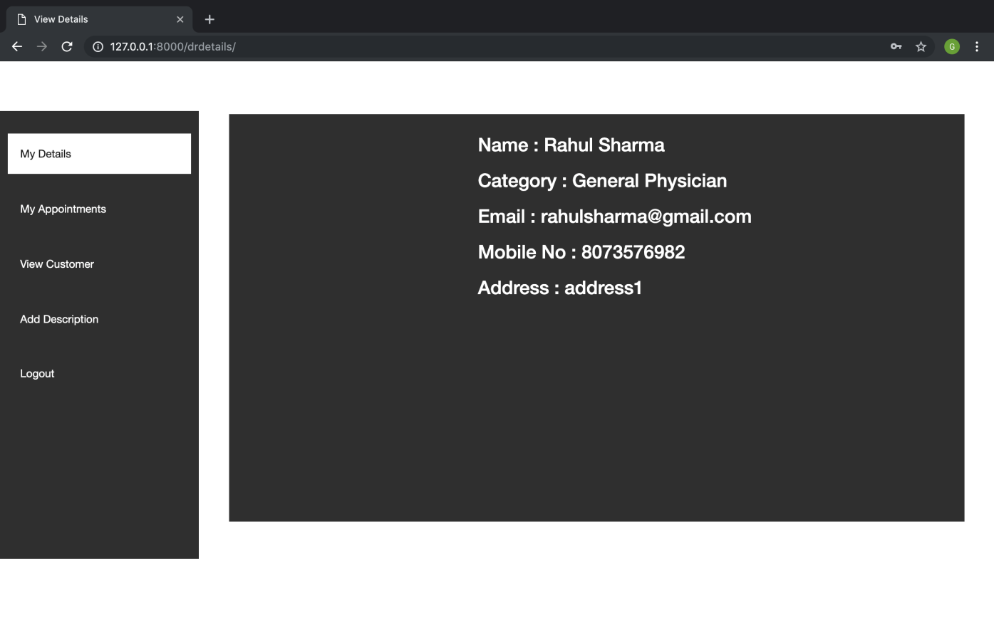

* **Doctor View Appointment**

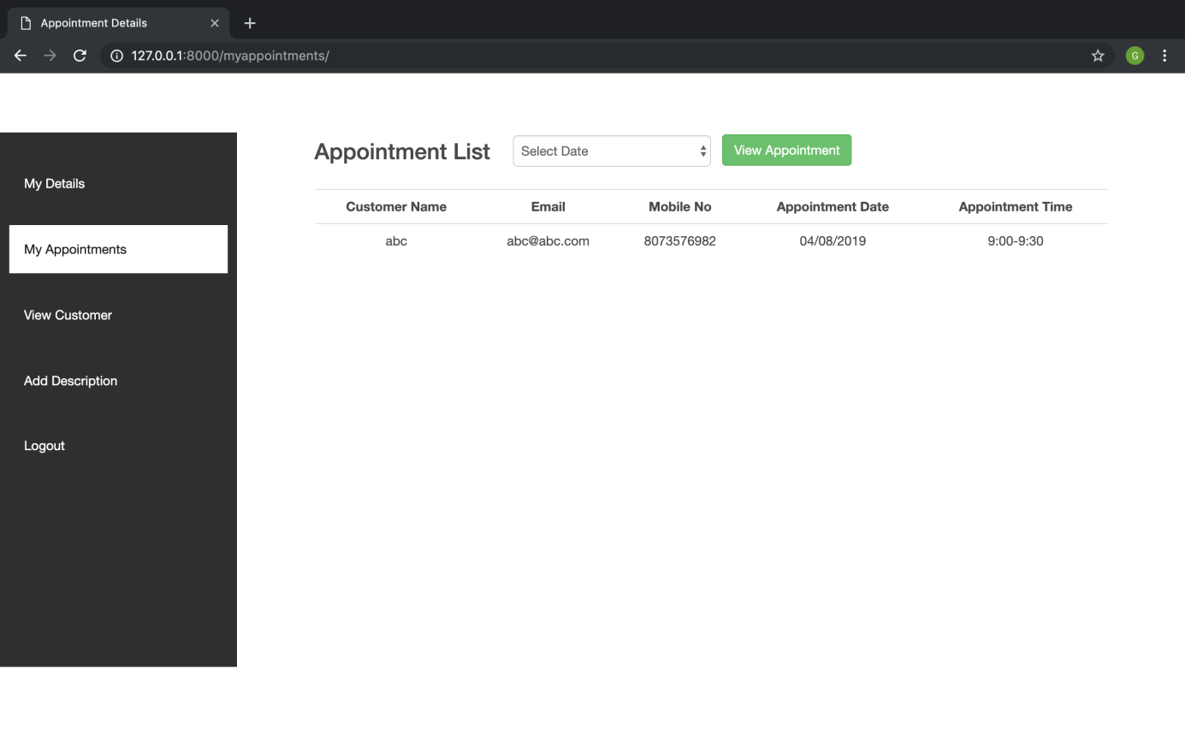

* **Doctor View Patient**

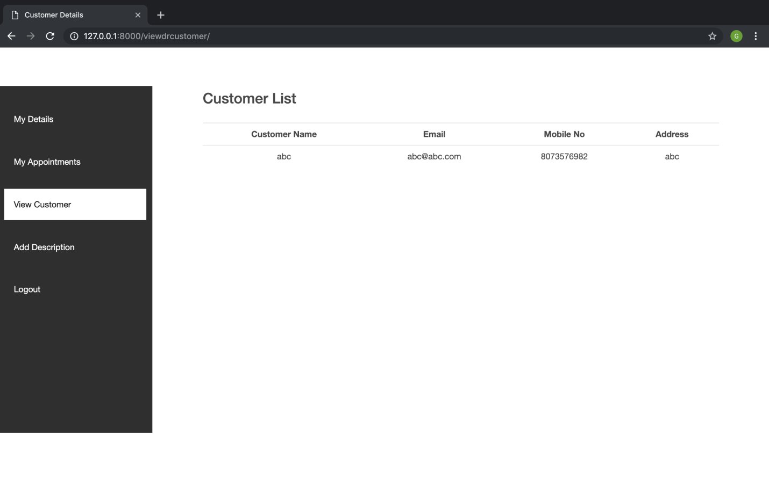

**4.4 System Development**

**4.4.1 Introduction to Python**

Python was designed at the National Research Institute by Guido van Rossum in the late eighties and mid-nineties for Mathematics and Computer Science in the Netherlands. Python is gotten from numerous different dialects, Modula-3, including ABC, C, C++, Small Talk, Algol-68, Unix shell, and other scripting dialects. It is copyrighted, and its source code is currently accessible under the “GNU General Public License (GPL)”. Python is presently kept up by a center improvement group at the organization, even though Guido van Rossum still holds a fundamental part in coordinating its encouraging. It is an interpreted, high level, object-oriented (OO), interactive scripting language. Python is intended to be exceedingly clear. It utilizes English keywords every now and again whereas different dialects use punctuation, and it has less scientific developments than different dialects.

* **Python is Interactive: I**n direct python interaction with an interpreter achieved through python prompt.
* **Python is Interpreted:** By the interpreter python processed at runtime. It is not required to compile the program before executing it. It is similar to PERL and PHP.
* **Python is Object-Oriented:** Python follows object-oriented programming approach.
* **Python is a Beginner's Language:** Beginner level programmer or learner can easily learn Python because it doesn’t pay much attention to syntax and supports the full range of development of applications by using simple text processing to World Wide Web (WWW) browser to games.

### 4.4.1.1 Object Orientation

### The first trademark, protest introduction ("OO"), alludes to a strategy for programming and dialect plan. Even though there are different explanation of OO, one essential is to plan to programme so the different sorts of information it controls are consolidated together with their related operations. Accordingly, information and code are combined into substances called objects.

### 4.4.1.2 Platform independence

### The second trademark, stage autonomy, implies that projects written in the Python dialect must run correspondingly on different equipment. One ought to have the capacity to compose a program once and run it anyplace. Most Python compilers accomplish this by aggregating the Python dialect code "most of the way" to byte code (mainly Python byte code) streamlined machine guidelines particular to the Python stage. The code then keeps running on a virtual machine (VM), a program written in local code on the host equipment that deciphers and executes bland Python byte code. Further, standardized libraries are given to enable access to highlights of the host machines, (for example, illustrations, threading and organizing) in brought together ways. Note that, even though there's an express ordering stage, eventually, the Python byte code is deciphered or changed over to local machine guidelines by the PYcharm compiler.

### 4.4.1.3 IDLE (Integrated Development & Learning Environment)

### IDLE has two main modes of programming.

### Interactive Mode Programming.

### Script Mode Programming.

### 

**4.4.1.4 Python Features**

Python's features include:

* **Easy to learn:-** There are few keywords, simple structure, and a clearly defined syntax in python. It allows the student to pick up the language quickly.
* **Easy to read:-** Python code is more clearly defined and visible to the eyes.
* **Easy to maintain:-** Python's source code is relatively easy to maintain.

**4.4.1.5 MY-SQL**

My-SQL is the most well known as “Open Source Relational SQL Database Management System”. It is outstanding amongst other RDBMS being utilized for creating different online programming applications. My-SQL is produced, showcased and upheld by MySQL AB, which is a Swedish organization. This instructional exercise will give you a fast begin to MySQL and make you OK with MySQL programming.

**4.4.1.6 Database**

A database is an alternate application that stores an aggregation of data. Each database has no less than one unmistakable APIs for making, getting to, supervising, looking and rehashing the data it holds. Diverse sorts of data stores can in like manner be used, for instance, records on the record structure or far-reaching hash tables in memory however data getting and forming would not be so fast and basic with those sort of structures.

Nowadays, we use databa sociale organization structures (RDBMS) to store and direct a gigantic volume of data. This is called social database since each one of the data is secured into different tables and relations are developed using basic keys or diverse keys known as Foreign Keys.

“A Relational Database Management System (RDBMS)” is an item that -

* Empowers us to execute a database with the help of tables, records and areas.
* Ensures the Referential Integrity between sections of various tables.
* Translates a SQL question and combines information from various tables.

**4.4.2 Django**

Django is a python based free and open-source web-based framework that encourages rapid development and clean, pragmatic design. Its primary goal is to ease the creation of complex, database-driven websites. It emphasizes on reusability of components, less code, rapid development.

Features of Django

* Reassuringly secure
* Ridiculously fast
* Exceedingly scalable

**4.4.3 Testing**

### Testing Technique

The techniques followed throughout the testing of the system are as under

#### **Black Box Testing**

Black box testing focuses on functional requirements of the software. Black Box testing focus on finding errors in the following categories

* Incorrect/missing function.
* Interface errors.
* Data structures or external database access errors.
* Performance errors.
* Initialization and termination errors.

#### **White Box Testing**

White box testing focuses on the internal operation and ensures that they work according to specifications. Using White box testing methods the tests cases that can be derived are:

* Every independent path within a module should be exercised at least once.
* All logical decisions should be an exercise on their true and false sides.
* All loops should be executed at their boundaries and within their operational bounds
* Internal data structures should be an exercise to to ensure their validity.

**CONCLUSION**

# The core reason for developing an Online Doctor Appointment System is to manage the hospital administrators in a convenient, fair and timely manner. Therefore the IT used should support the core objective of the system if it is to remain relevant to the hospital. Still a lot can be done in the IT department to make available technology useful. This system may involve training of the hospital staffs on how to enter data in the right and relevant way and the management to keep updating the hardware and software requirements of the system. IT and computer systems need to upgrade as more and more IT facilities software are introduced nowadays in the IT market.

**REFERENCES**

* SDLC Waterfall Model.htm Copyright © Tutorialspoint, https://www.tutorialspoint.com/sdlc/pdf/sdlc_waterfall_model.pdf (accessed February 24, 2019).
* "Common Gateway Interface - Wikipedia." Insert Name of Site in Italics. N.p., n.d. Web. 12 Mar. 2019 <https://en.wikipedia.org/wiki/Common_Gateway_Interface>

**CONTRIBUTION OF EACH MEMBER**

1. Bhawna Chawla - Template development and creation of Migrations.
2. Gaurav Taluja – Back-end of website development, how bookings are done etc.